**Employees Data Analysis**

**Task 1 (EDA) – Estarta AI training**

**Nashat Al-Farajat**

**Introduction (about the Data Set):** This dataset contains detailed employee information from a company, with 1,000 records. Each entry includes details such as employee ID, name, job title, department, unit, gender, age, salary, bonus %, hire and exit dates, country and city. The data can be used to explore employee details, pay levels, and how teams are set up within the company.

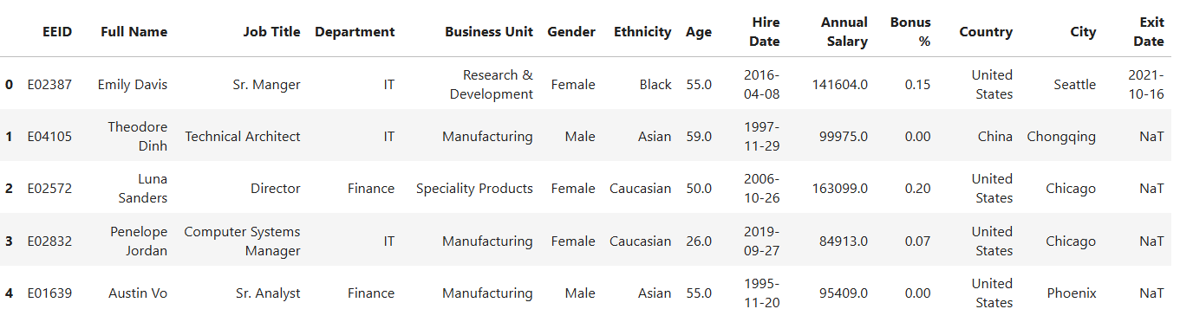

**Initial Data Exploration:** Before cleaning and processing, a basic exploration was conducted to understand the structure and content of the dataset.

* **Dataset Shape**: The dataset contains **1,000 rows** and **14 columns**.
* **Data Types** and Non-Null Counts (Several columns contain missing values, which will be addressed in the data cleaning stage).

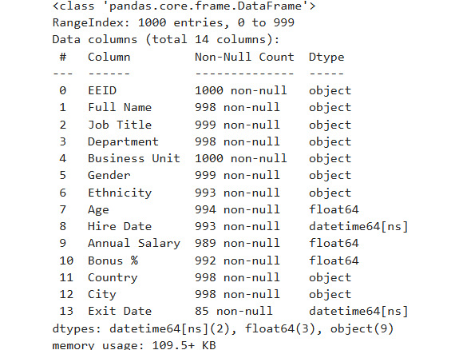

* **Summary Statistics** (Selected Numerical and Date Columns)

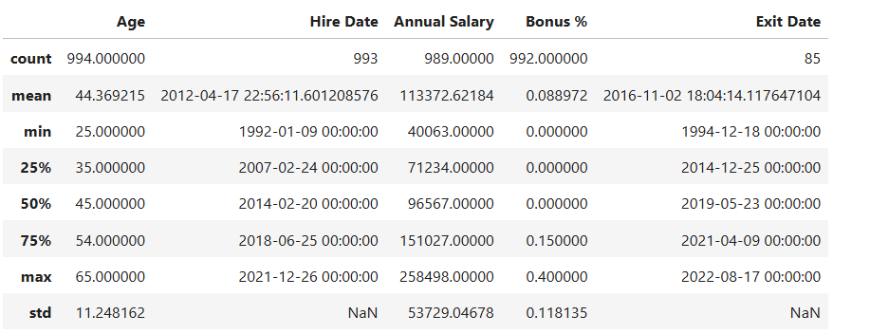

**Data Cleaning**

**Handling Missing Values:** The table below summarizes the number of missing values in each column.

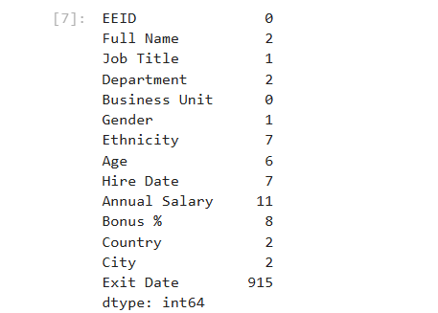

**Note:** Missing values in **Exit Date** are normal because they indicate employees who are still working at the company.

**Methods used**:

1. **Dropping the rows with missing values**: Rows with missing values in **Full Name**, **Job Title**, **Ethnicity**, **Hire Date**, **Country**, and **City** were removed because these fields are essential for accurate identification and analysis. For example, when **City** is missing, **Country** is often missing too, making it impossible to reliably fill these values, Initially, the dataset contained 1,000 rows. After removing records with missing values in critical fields, 993 rows remain, meaning **only 0.7% of the data was removed.**

Number of missing values in each column after dropping the rows.

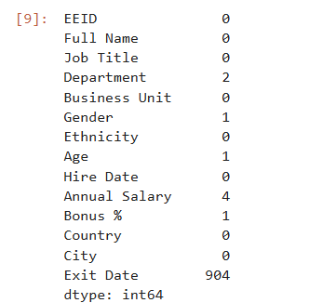

#### 2 - Manual Filling of Missing Departments and Gender:

For the small number of missing values in the **Department** column (2 rows), the departments were manually filled by referencing the corresponding **Job Title**. This approach leverages the logical relationship between an employee’s role and their department to ensure accurate completion of missing data.

For the two employees with missing **Department** values, the **Job Titles** were **System Administrator** and **Business Partner**. Based on these roles, the missing departments were manually filled as follows:

* **System Administrator** → **IT Department.**
* **Business Partner** → **Human Resources Department.**

This ensured the dataset remains accurate and consistent.

For the single missing value in **Gender**, the employee’s name was **Nova**, which is typically a female name. Based on this, the missing gender was manually filled as **Female**.

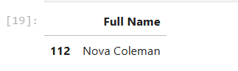

1. **Filling by Mean for department(same department, business unit and job title), bonus % and age**:

Missing values in **Annual Salary** were filled using the **mean salary** of employees who share the same **Department**, **Business Unit**, and **Job Title**.  
This method provides a more accurate estimation by considering employees in similar roles and organizational context, rather than using a general company-wide average.

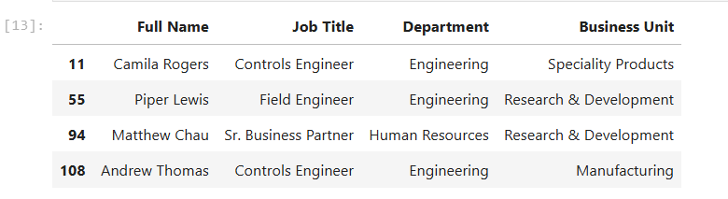

Missing values in **Bonus %** were filled using the same method as **Annual Salary** — by calculating the average bonus of employees with the same **Department**, **Business Unit**, and **Job Title**. This helps maintain consistency within similar employee groups.

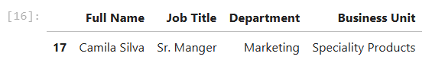

For the only missing values in the **Age** column, the overall **mean age** of all employees (~44) was used. Since age is less tied to specific roles or departments, a global average was considered appropriate.

**Handling duplicates:**

The dataset was checked for duplicate rows, and **no duplicates were found**. Therefore, no action was needed in this step.

**Handling outliers:**

The **Annual Salary** and **Age** columns were examined for outliers using **interquartile range (IQR)** and **box plot** analysis. No significant outliers were detected, so no records were removed or modified in this step.

**Changing the first five rows:**

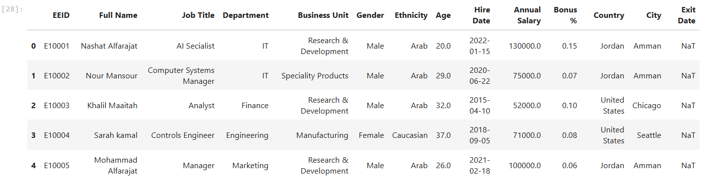

**Row with largest salary:**



**Group by Department, getting average salary and average age:**

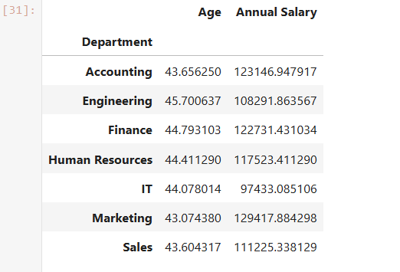

**Group by Department + Ethnicity, maximum age, minimum age, median salary:**

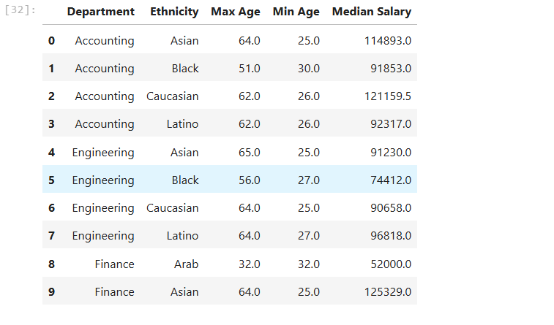

Note: the cleaned and prepared dataset is saved to a new excel file.

**Plotting and Gaining Insights**

1. **Line chart showing the number of employees hired each year**

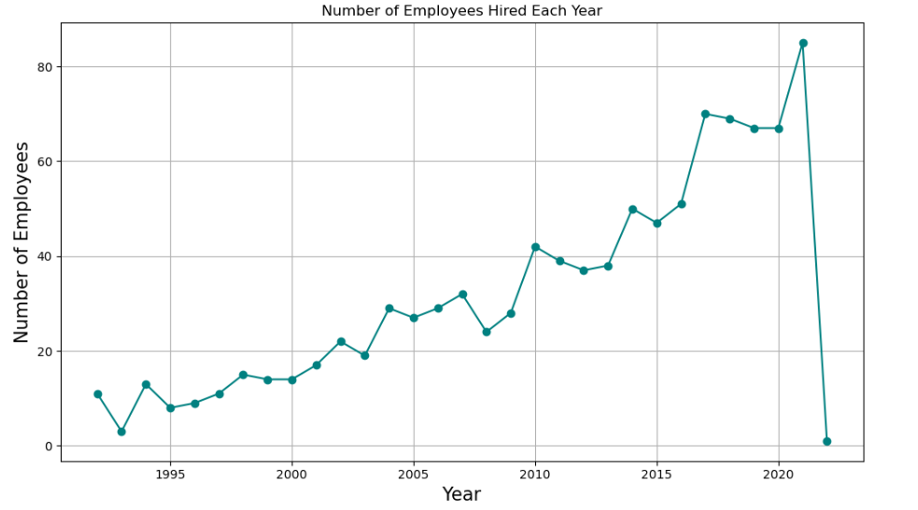

The Line chart shows that the number of employees hired has increased each year, with **2021** being the year with the highest number of new hires.

**2- Bar chart showing the number of employees in each department, based on gender**

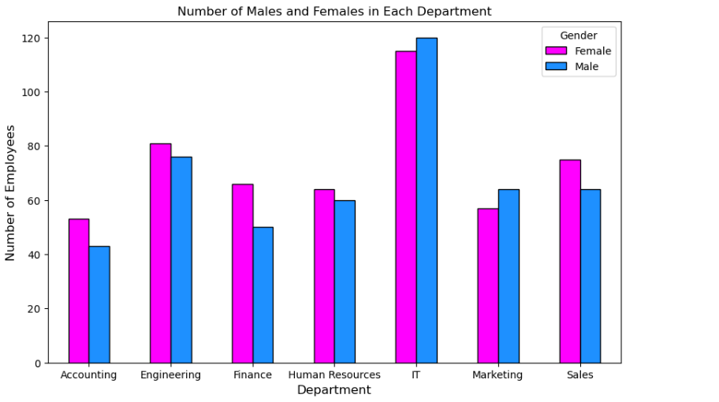

The **bar chart** shows the number of employees in each department, categorized by **gender**. In most departments, the number of **female employees is slightly higher** than males. However, in the **IT** and **Marketing** departments, **male employees slightly outnumber females**. The chart also shows that the **IT department** has had the **highest total number of employees** over the years.

**3- Pie chart showing the ethnicity proportion in the company**

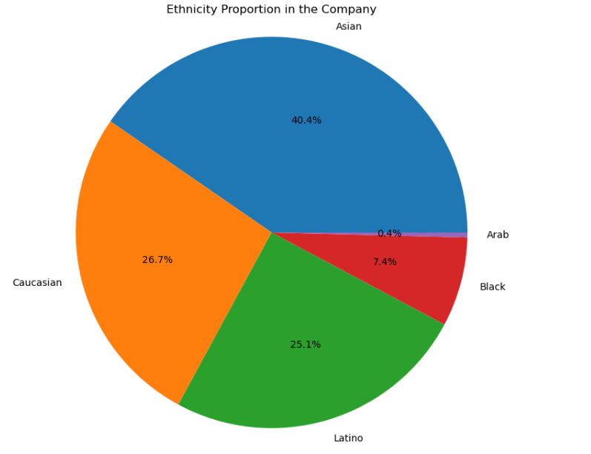

The **pie chart** shows the **ethnicity** of employees in the company. **Asian** employees make up the largest group at **40.4%**, followed by **Caucasian** (26.7%) and **Latina** (25.1%). **Black** employees are 7.4%, and **Arab** employees are the smallest group at 0.4%.

**4- Correlation Heatmap of Numeric Variables**

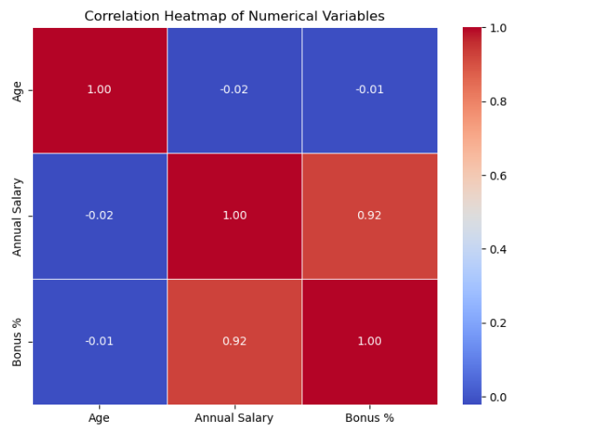

The **correlation heatmap** shows the relationships between the numeric columns: **Annual Salary**, **Age**, and **Bonus %**. It shows that **Age** has little to no correlation with **Salary** or **Bonus %**, while **Bonus %** and **Annual Salary** are **strongly correlated.**